Category Overview
1:07:38
六月 26, 2019
Unnamed Project
Time Units:
Replications:
10
Hours
Values Across All Replications
Key Performance Indicators
Average
System
Number Out
1,781
Model Filename:
Page
of
1
5
G:\a- OMSA\ISYE-6501\hw6\new

Category Overview
1:07:38
六月 26, 2019
Unnamed Project
Time Units:
Replications:
10
Hours
Values Across All Replications
Entity
Time
VA Time
Maximum
Average
Minimum
Average
Half Width
Average
Minimum
Value
Maximum
Value
0.02491345
Entity 1
.00
0.02439529
0.02520907
0.00844006
0.1188
NVA Time
Maximum
Average
Minimum
Average
Half Width
Average
Minimum
Value
Maximum
Value
0.00
Entity 1
.00
0.00
0.00
0.00
0.00
Wait Time
Maximum
Average
Minimum
Average
Half Width
Average
Minimum
Value
Maximum
Value
0.05557122
Entity 1
.01
0.04169051
0.07600261
0.00
0.2329
Transfer Time
Maximum
Average
Minimum
Average
Half Width
Average
Minimum
Value
Maximum
Value
0.00
Entity 1
.00
0.00
0.00
0.00
0.00
Other Time
Maximum
Average
Minimum
Average
Half Width
Average
Minimum
Value
Maximum
Value
0.00
Entity 1
.00
0.00
0.00
0.00
0.00
Total Time
Maximum
Average
Minimum
Average
Half Width
Average
Minimum
Value
Maximum
Value
0.08048467
Entity 1
.01
0.06664208
0.1011
0.00970921
0.2635
Other
Number In
Maximum
Average
Minimum
Average
Half Width
Average
Entity 1
28.19
1810.90
1875.00
1751.00
Number Out
Maximum
Average
Minimum
Average
Half Width
Average
Entity 1
24.89
1781.00
1857.00
1740.00
WIP
Maximum
Average
Minimum
Average
Half Width
Average
Minimum
Value
Maximum
Value
24.2224
Entity 1
2.50
19.9373
30.7723
0.00
78.0000
Model Filename:
Page
of
2
5
G:\a \OMSA\ISYE-6501\hw6\new

Category Overview
1:07:38
六月 26, 2019
Unnamed Project
Time Units:
Replications:
10
Hours
Values Across All Replications
Queue
Time
Waiting Time
Maximum
Average
Minimum
Average
Half Width
Average
Minimum
Value
Maximum
Value
0.03175333
ID checker.Queue
.01
0.02173886
0.05395455
0.00
0.1658
0.02675010
Queue1.Queue
.00
0.01838428
0.03668544
0.00
0.1308
0.02422012
Queue2.Queue
.00
0.01574415
0.03405901
0.00
0.1279
0.02259942
Queue3.Queue
.00
0.01362638
0.03266692
0.00
0.1192
0.02193733
Queue4.Queue
.01
0.01166858
0.03172182
0.00
0.1075
Other
Number Waiting
Maximum
Average
Minimum
Average
Half Width
Average
Minimum
Value
Maximum
Value
9.6165
ID checker.Queue
2.15
6.4718
16.5827
0.00
54.0000
2.1502
Queue1.Queue
.37
1.4673
2.9501
0.00
10.0000
1.9154
Queue2.Queue
.37
1.2451
2.6927
0.00
10.0000
1.6752
Queue3.Queue
.37
1.0250
2.4464
0.00
9.0000
1.4397
Queue4.Queue
.37
0.7492
2.2152
0.00
9.0000
Model Filename:
Page
of
3
5
G:\a\OMSA\ISYE-6501\hw6\new

Category Overview
1:07:38
六月 26, 2019
Unnamed Project
Time Units:
Replications:
10
Hours
Values Across All Replications
Resource
Usage
Instantaneous Utilization
Maximum
Average
Minimum
Average
Half Width
Average
Minimum
Value
Maximum
Value
0.9300
Resource 1
.01
0.9139
0.9528
0.00
1.0000
0.9946
Scanner 1
.00
0.9875
0.9991
0.00
1.0000
0.9801
Scanner 2
.00
0.9736
0.9889
0.00
1.0000
0.9192
Scanner 3
.01
0.8989
0.9624
0.00
1.0000
0.8114
Scanner 4
.04
0.7431
0.9202
0.00
1.0000
Number Busy
Maximum
Average
Minimum
Average
Half Width
Average
Minimum
Value
Maximum
Value
3.7202
Resource 1
.04
3.6558
3.8113
0.00
4.0000
0.9946
Scanner 1
.00
0.9875
0.9991
0.00
1.0000
0.9801
Scanner 2
.00
0.9736
0.9889
0.00
1.0000
0.9192
Scanner 3
.01
0.8989
0.9624
0.00
1.0000
0.8114
Scanner 4
.04
0.7431
0.9202
0.00
1.0000
Number Scheduled
Maximum
Average
Minimum
Average
Half Width
Average
Minimum
Value
Maximum
Value
4.0000
Resource 1
.00
4.0000
4.0000
4.0000
4.0000
1.0000
Scanner 1
.00
1.0000
1.0000
1.0000
1.0000
1.0000
Scanner 2
.00
1.0000
1.0000
1.0000
1.0000
1.0000
Scanner 3
.00
1.0000
1.0000
1.0000
1.0000
1.0000
Scanner 4
.00
1.0000
1.0000
1.0000
1.0000
Model Filename:
Page
of
4
5
G:\a\OMSA\ISYE-6501\hw6\new

Category Overview
1:07:38
六月 26, 2019
Unnamed Project
Time Units:
Replications:
10
Hours
Values Across All Replications
Resource
Usage
Scheduled Utilization
Maximum
Average
Minimum
Average
Half Width
Average
Resource 1
.01
0.9300
0.9528
0.9139
Scanner 1
.00
0.9946
0.9991
0.9875
Scanner 2
.00
0.9801
0.9889
0.9736
Scanner 3
.01
0.9192
0.9624
0.8989
Scanner 4
.04
0.8114
0.9202
0.7431
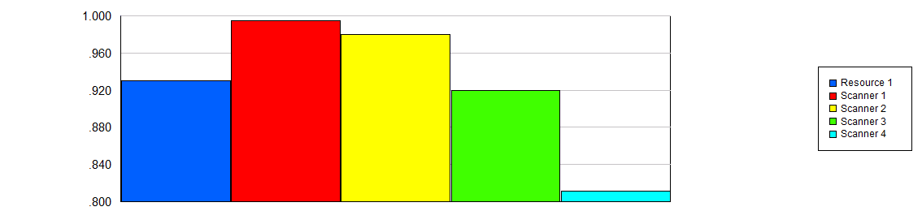
Total Number Seized
Maximum
Average
Minimum
Average
Half Width
Average
Resource 1
25.77
1796.50
1872.00
1749.00
Scanner 1
3.31
480.10
487.00
474.00
Scanner 2
2.84
472.80
480.00
468.00
Scanner 3
6.11
442.20
460.00
430.00
Scanner 4
17.36
389.70
443.00
356.00
Model Filename:
Page
of
5
5
G:\a\OMSA\ISYE-6501\hw6\new
